Documentation for the Nano-Mouse Application

By: Jason Nixon

# 1. Application Structure:

This part of the documentation will explain the layout of each method used to create the application for the Nano-Mouse:

* **ButtonStart.Click()**: This is the only method for the first screen of the application that control the start button used to enter into the second screen.
* **ConnectList.BeforePicking():** This method controls what happens before the device is connected to the mouse. Before its connected there will be a rectangular button that on the left side of the screen that we have the word “Connection” on it will a red background, this indicates that the android device has not paired with a Bluetooth module.
* **ConnectList.AfterPicking():** This method function is to display a listview of all the paired devices and when one is picked then the user will have control of the mouse. After the user has picked a paired device the “Connection” button’s background will change from red to green to indicate that a connection has been established.
* **ConnectButton.Click():** This method controls the connection between the devices. When there is not a connection already established then the user will be able to connect or if there is a connection already established then it disconnects.
* **Clocks.Timer():** This method uses four global variables that contain values that are sent over in bytes to the Nano-Mouse and this values are displayed on the android device screen with values ranging from 100 to -100.

# 2. Arduino Structure:

This part will explain how and what is been sent over from the android device to the Nano-Mouse:

* **Messages_ino.ino:** This code is loaded on to the Arduino Nano, but when uploading the code it is necessary for the user to take out the RX/TX cable from the board or the code won’t load. The way the code works is that it detects if there has been a serial connection between both devices, when there is the values that are being displayed on the android device are actual the values being sent over to the Nano-Mouse in bytes in a Char array and the values determine the amount of power going into each servo motors.

# 3. UML Diagram:

This UML Diagram to show the relationship between the application and the Nano-Mouse:

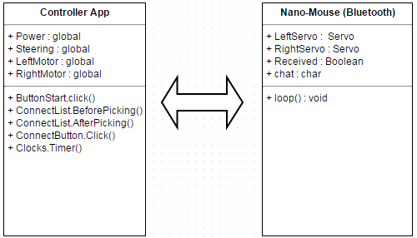

# 4. Application Source Code:



 